Thinkathon writeup

**Submitted by: Raksham Tiwari, B18BB028**

**Modifying Phage against Antibiotic Resistance**

**Introduction**

How does a doctor treats patients with bacterial diseases? He would prescribe an antibiotic but what if this antibiotic fails to work? That is, what if the disease-causing bacteria becomes ***Antibiotic Resistant***? This project brings a novel approach to Fight Antibiotic Resistance with the help of a ***modified phage***.

Antibiotics are drugs that fight bacterial infections either by killing bacteria or slowing its growth. They act by attacking the bacterial cell wall, interfering with bacterial reproduction. An estimated 35000 Americans die of antibiotic-resistant infections every year [[1]]. Due to misuse and overuse of antibiotics, bacteria have started evolving a **defense mechanism** against antibiotic drugs.  Bacteria can become Antibiotic-Resistant using resistance mechanisms [[2]]. Usually present in plasmids, antibiotic-resistant genes can be transferred to other bacteria via **Horizontal gene transfer** spreading the resistance.

A possible solution to this is ‘[Phage Therapy](https://www.ncbi.nlm.nih.gov/pmc/articles/PMC90351/)’ where we use bacteriophages to kill bacteria. This works with the phage performing lytic and lysogenic cycles. A phage has receptors to put its RNA into a specific bacterium. Hacking host replication system, a phage multiplies itself and bursts open the cell killing the bacteria with a huge population of itself.

**Problem with the current approach:**

This therapy fails with the occurrence of ‘Phage Resistance’ [[3]]’. Bacteria can resist phage attack through different mechanisms [[4]], including spontaneous mutations, restriction-modification systems, and adaptive immunity via the **CRISPR-Cas system**. Spontaneous mutations are the main mechanisms driving both phage resistance and phage–bacterial coevolution [[5]]. Phage and bacteria co-evolve to fight against each other, once bacteria become phage resistant, phage modifies itself to again kill the bacteria.

Then what can be done? If nothing is done, then there is no new drug, even if it comes in, there is no sure time period till when it may remain effective. To fight this problem, we come with a novel approach of modifying the phage by removing the gene responsible for the lysogenic cycle and replacing it with an operon of bacterial enzymes (lysozyme and lipase)  so that even if the bacteria become resistant, it will be killed.   The **mind map** representing the idea is shown below. It has been divided into 6 subtopics to cover the project. There is a basic plan, an execution, and a verification present on the map.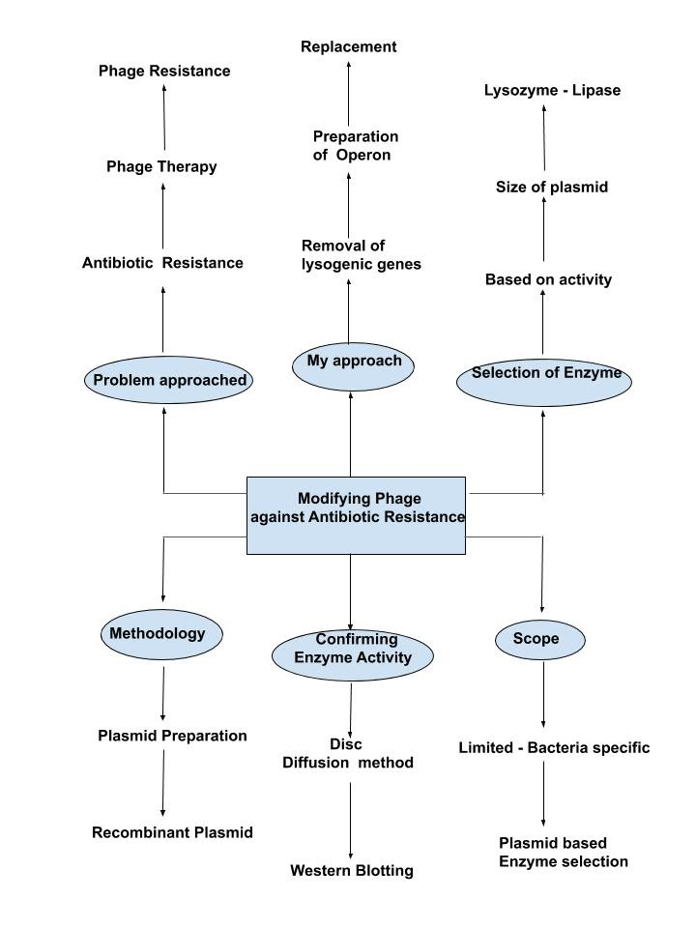

**Final approach to solve the problem: Modifying the phage**

**W**e have certain human enzymes for example lysozyme and lipase which are responsible for killing bacteria. **Lysozyme** hydrolyses the bond between N-acetyl glucosamine and N-acetyl muramic acid (muramidase **activity**) leading to degradation of peptidoglycan in the cell wall of Gram-positive bacteria. Lipase shows lipolytic activity. **Cloning** is the concept of the **introduction of foreign genetic material** to some system. For example, introducing a non-native operon to a Bacteriophage.

Our aim is to kill the bacteria even if it becomes phage resistant. For our purpose, the genes responsible for lysogeny are of no use. Instead, we can construct a new operon and integrate it in place of lysogeny responsible genes. Thus, ***cloning a new sequence*** and, hence forming a **Recombinant DNA**. To design an operon, we need a promoter, terminator, Ribosome binding sites, coding gene sequence (with start-stop codons), and restriction sites.

The template for the operon should be:

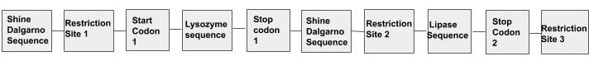

We have gene sequences of enzymes taken from the NCBI gene bank. Also, we have sequences of multiple restriction enzyme sites used like Hindiii, BSSHii, EcoR1 etc. taken from New England Labs (neb website)[[6]].

After the replacement of the lysogenic genes, once the genes are expressed, they will kill the bacteria by their enzymatic activity. Thus, even if the bacteria become phage resistant, it will be killed thus successfully attaining our aim.

Note that it is important to optimize the enzyme codons as they are human enzymes and for expression in the bacteria, the same codons may not work.

**Verification:**

**W**e have used lysozymes and lipase as examples of enzymes to be taken. For the selection of the enzymes, we need to verify that death has been caused by their action on the specific bacteria. This can be done using Disc Diffusion and Western Blotting methods. We take a Petri plate which has a medium with agar. Now a pathogenic bacteria (here Ecoli ) is streaked on the medium. Next, the Disk Diffusion method is used where the disks contain our enzymes. As per the activity they give Zone of Inhibitions. Now the proteins from the zone of inhibition are separated using SDS Page method. After the transfer of proteins to a membrane by the blotting tank, the proteins are then marked with specific antibodies and then checked for the presence of specific proteins based on their radioactivity.

**Methodology:**

1. A synthetic operon is prepared after the selection of Enzymes based on their activity.
2. Plasmid genes are separated and purified. Then Recombinant plasmid is prepared with the help of Restriction and ligase enzymes, by digestion and ligation. Here, the section of gene sequence responsible for lysogeny is replaced with a newly made operon.
3. The solution is transferred to a filter paper disc.
4. Disc Diffusion method is then used in a streaked Petri plate to attain a zone of inhibitions.
5. Proteins are separated from the zone of inhibitions using the SDS-PAGE method.
6. Antibodies with specific markers are then used for the identification of desired proteins.

We have made a construct of operon using gene sequences from various sites like NCBI gene bank and New England labs (neb) website. The link for which is given below:

<https://drive.google.com/open?id=153OtiVrXEU1sXjiSq-mJ09ZfC6gvXvg_>

# Now for our project, we have taken *Streptococcus pneumoniae*, MM1 phage. Both lysozyme and lipase activities are found to be bactericidal [[7]][[8]] [[9]].

# We have assumed that we will use promoter sequence of the gene to be replaced itself.

**Scope and limitations:**

**T**he approach if gets successful can help to treat antibiotic resistance and thus saving the lives of many people. There are certain limitations to the approach which can be optimized later. For example, it is a bacteria-specific approach and enzymes may not work on multiple bacteria. Also, the enzyme selection process is time taking as you need to select. Also the gene sequence length should be adequate enough to be carried by a plasmid.

**Resources:**

1. .<https://www.scientificamerican.com/article/cdc-report-finds-35-000-americans-die-of-antibiotic-resistant-infections-each-year/>
2. <https://www.cdc.gov/drugresistance/about/how-resistance-happens.html>
3. <https://www.ncbi.nlm.nih.gov/pmc/articles/PMC6070868/>
4. <https://www.nature.com/articles/nrmicro2315/>
5. <https://onlinelibrary.wiley.com/doi/pdf/10.1111/1574-6976.12072>
6. <https://international.neb.com/search#q=hindiii&t=_BD3F1B0F-DB56-4EF7-AC3E-FEAA9BDC74A4&sort=relevancy>
7. <https://www.ncbi.nlm.nih.gov/pmc/articles/PMC5750712/>
8. <https://www.ncbi.nlm.nih.gov/pubmed/26298002>
9. <https://www.ncbi.nlm.nih.gov/pmc/articles/PMC1539626/>